Dark Matter Demonstration Machine

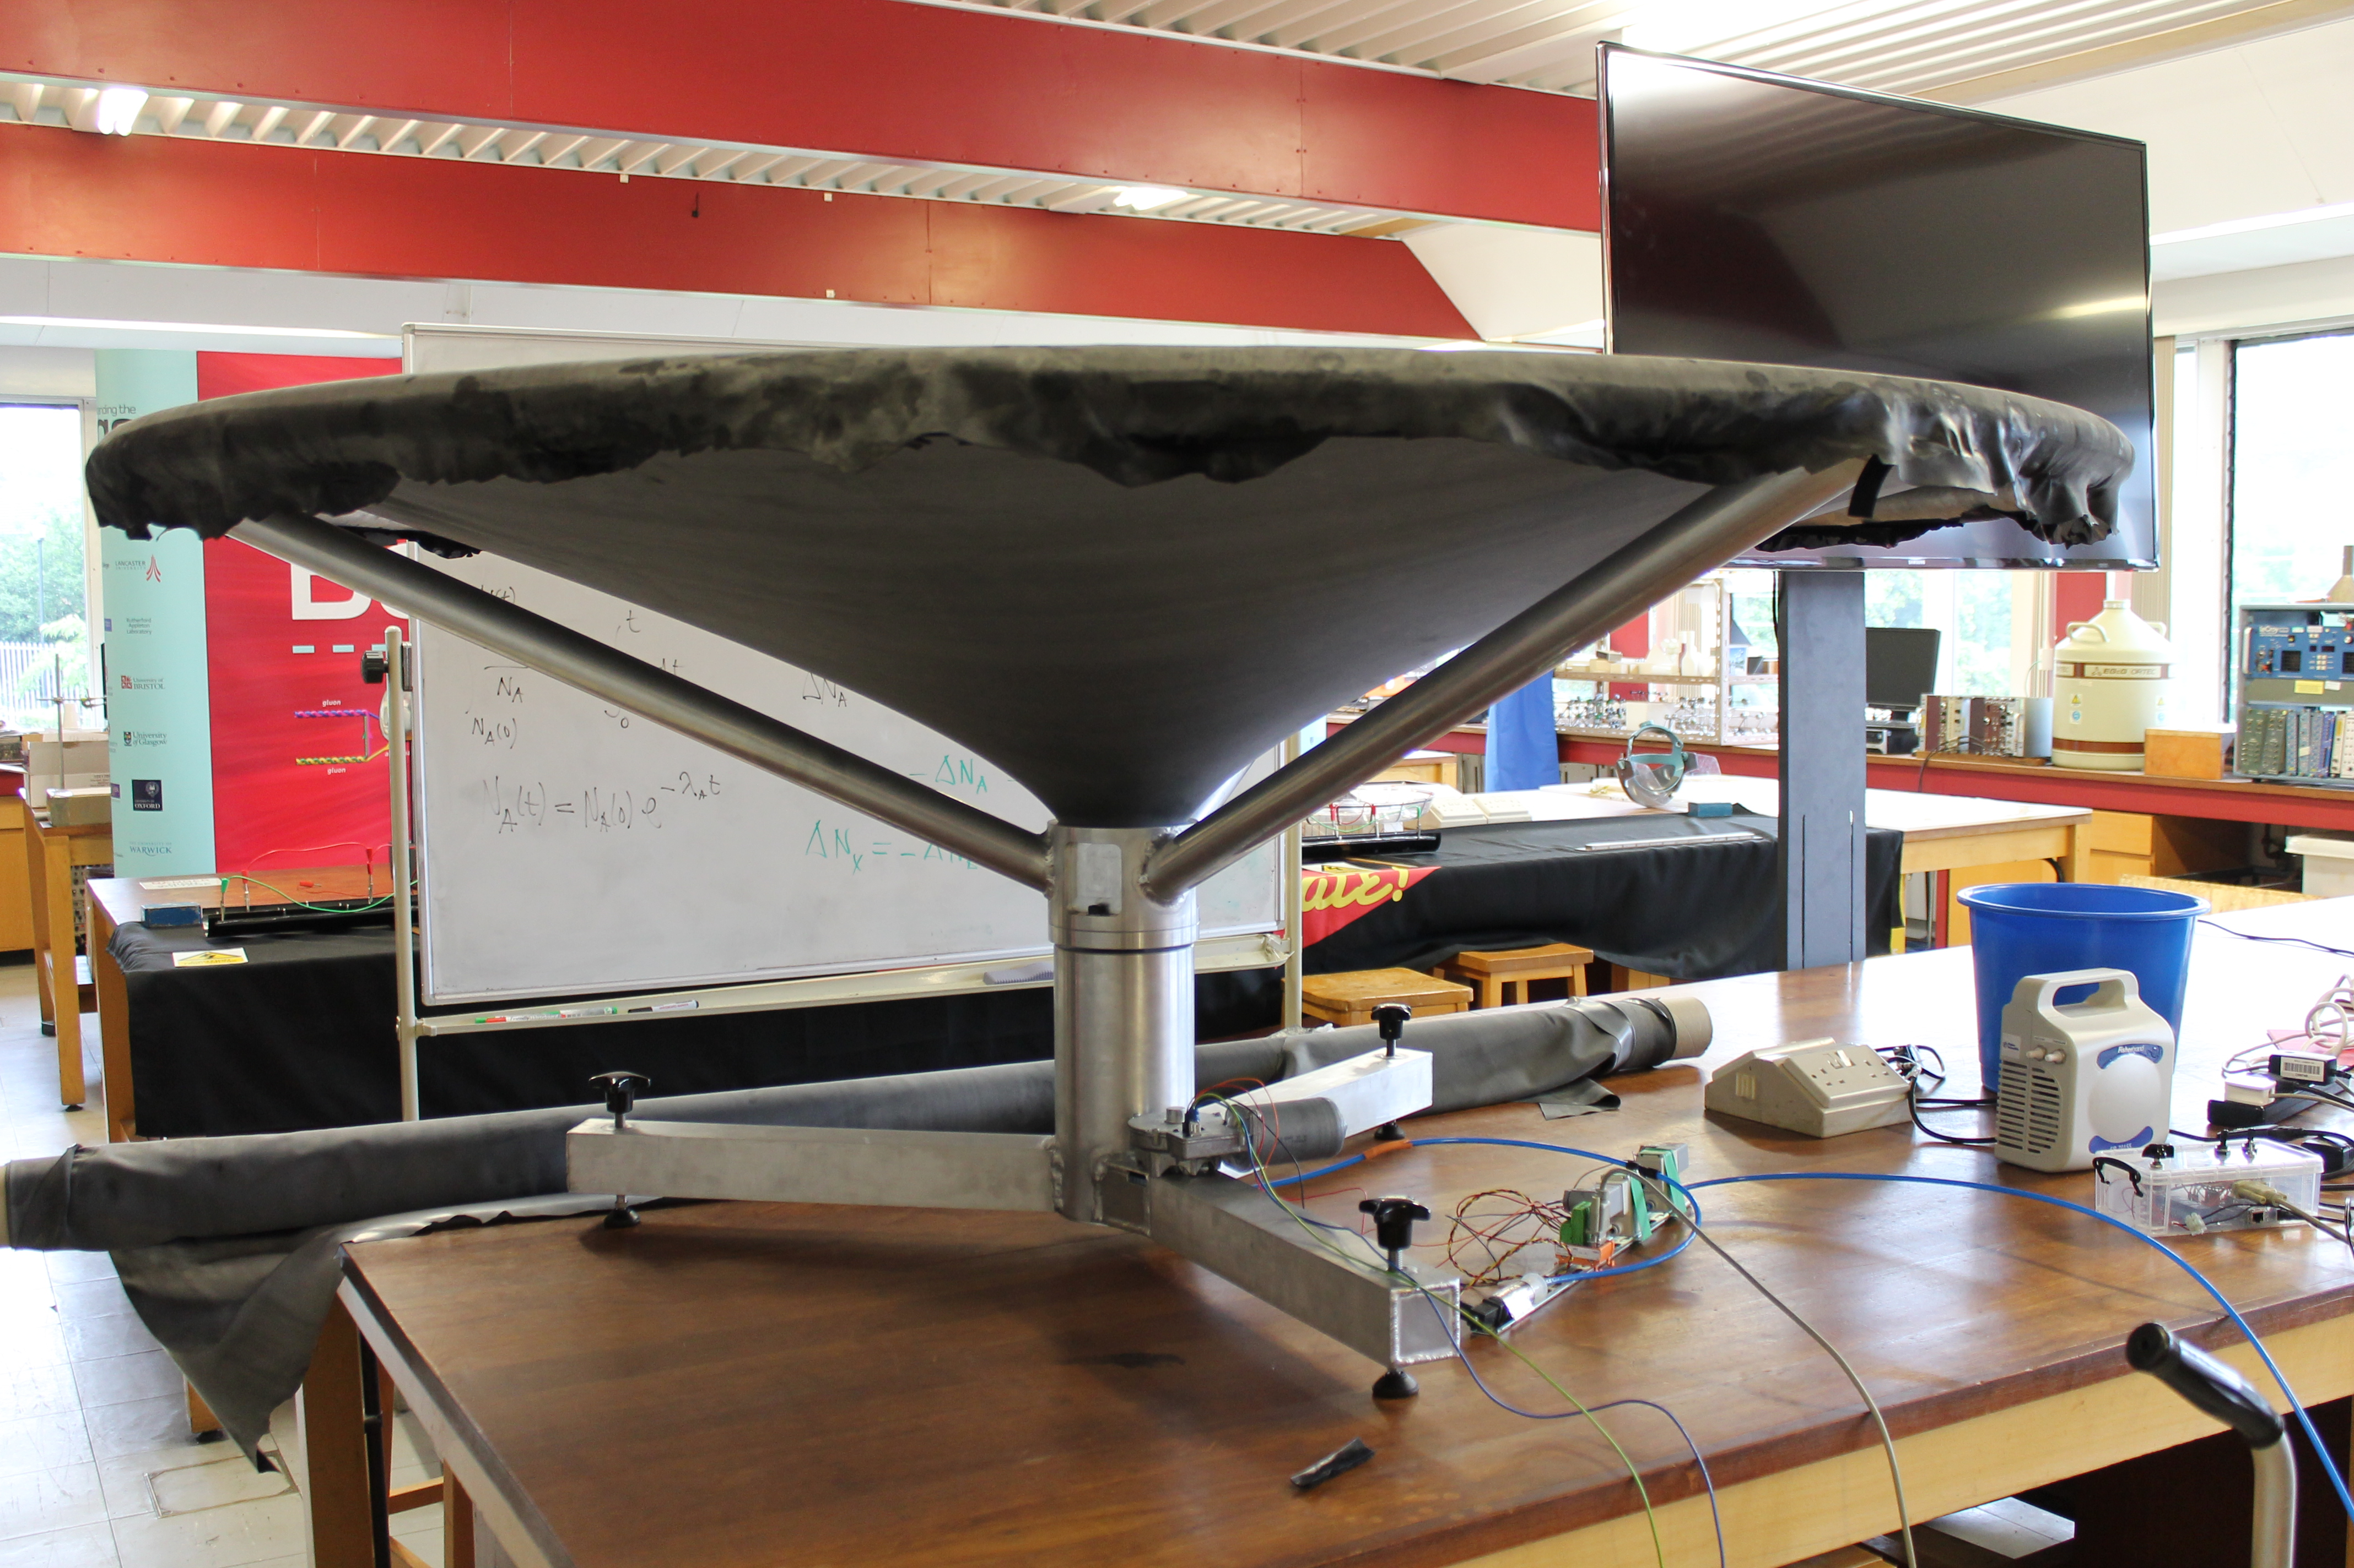

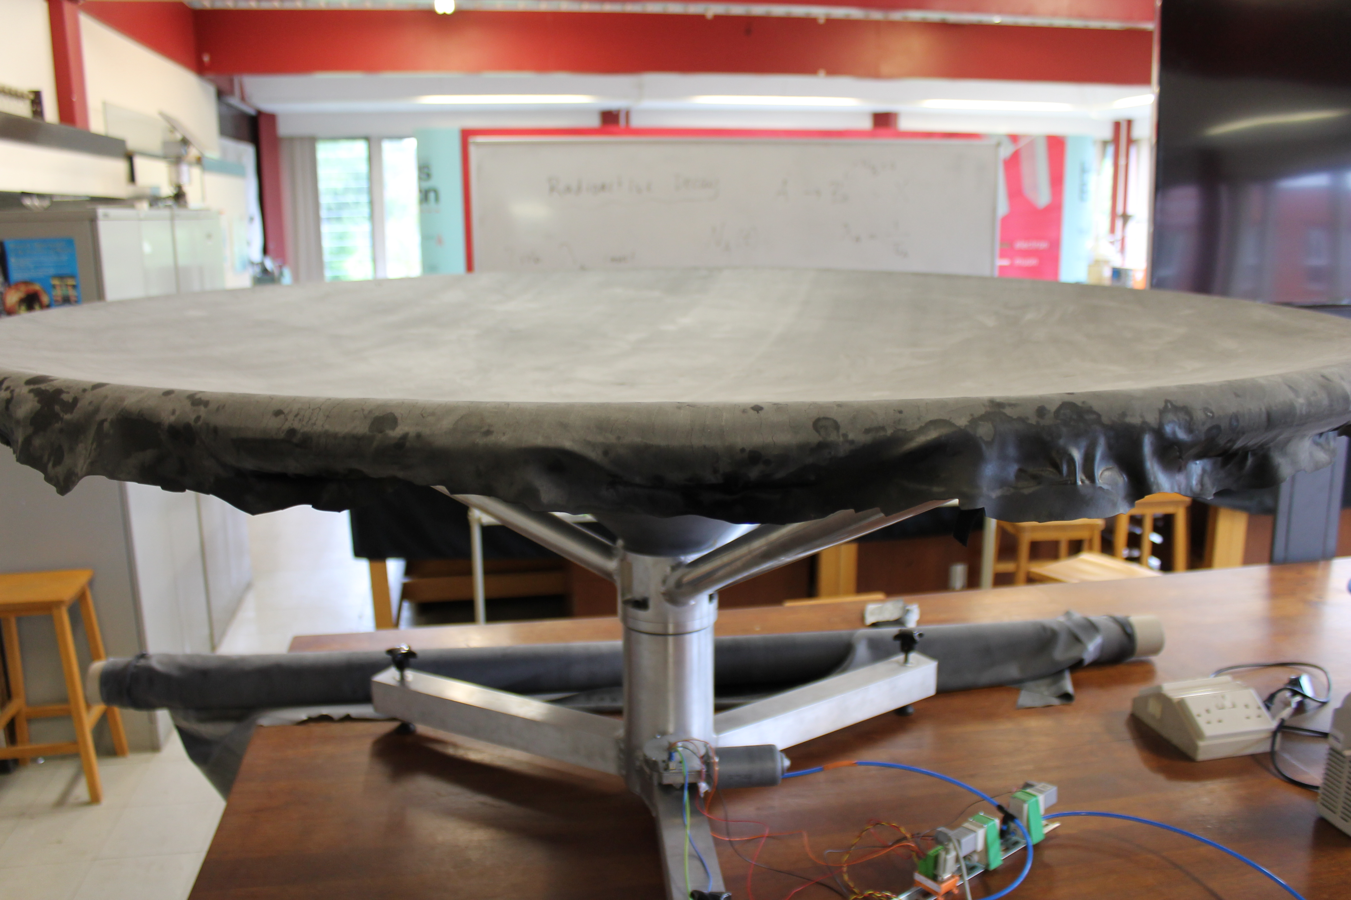

Set-up

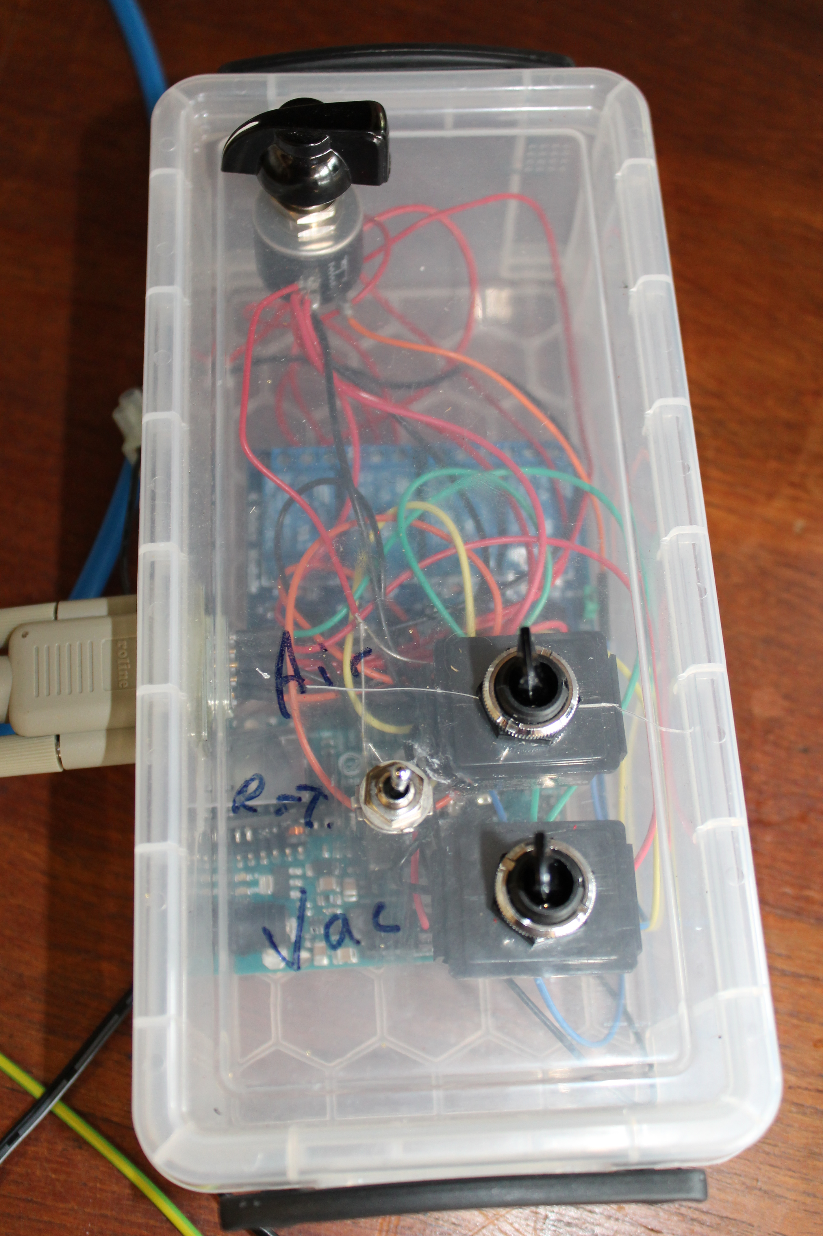

The control box.

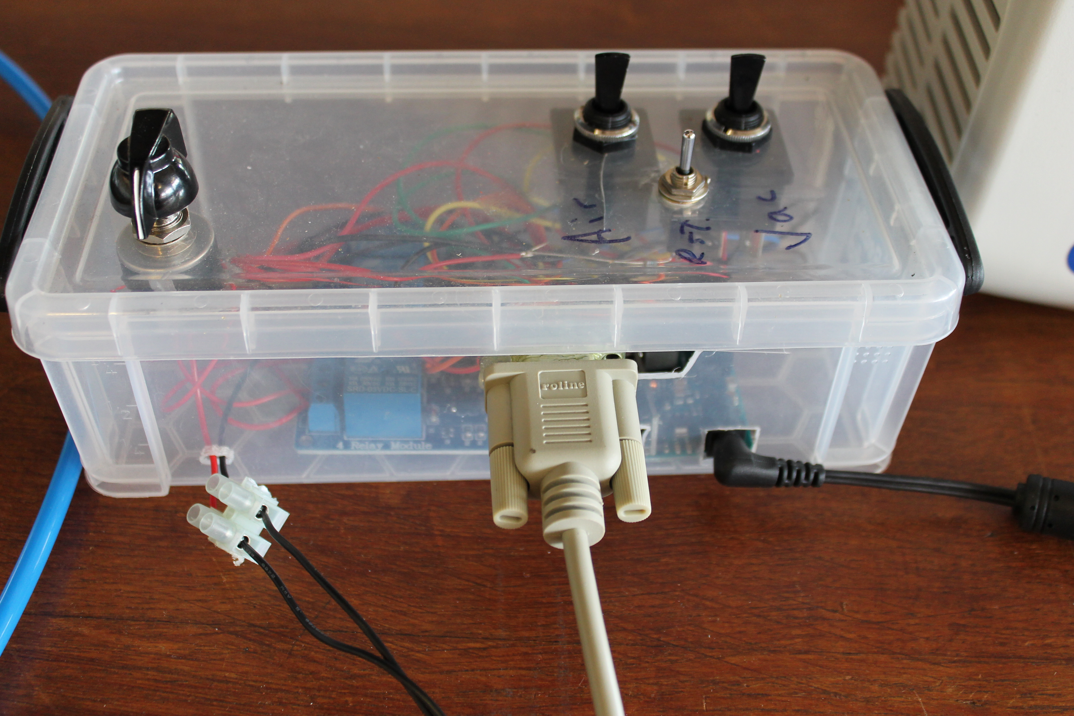

Wires that connect to the control box.

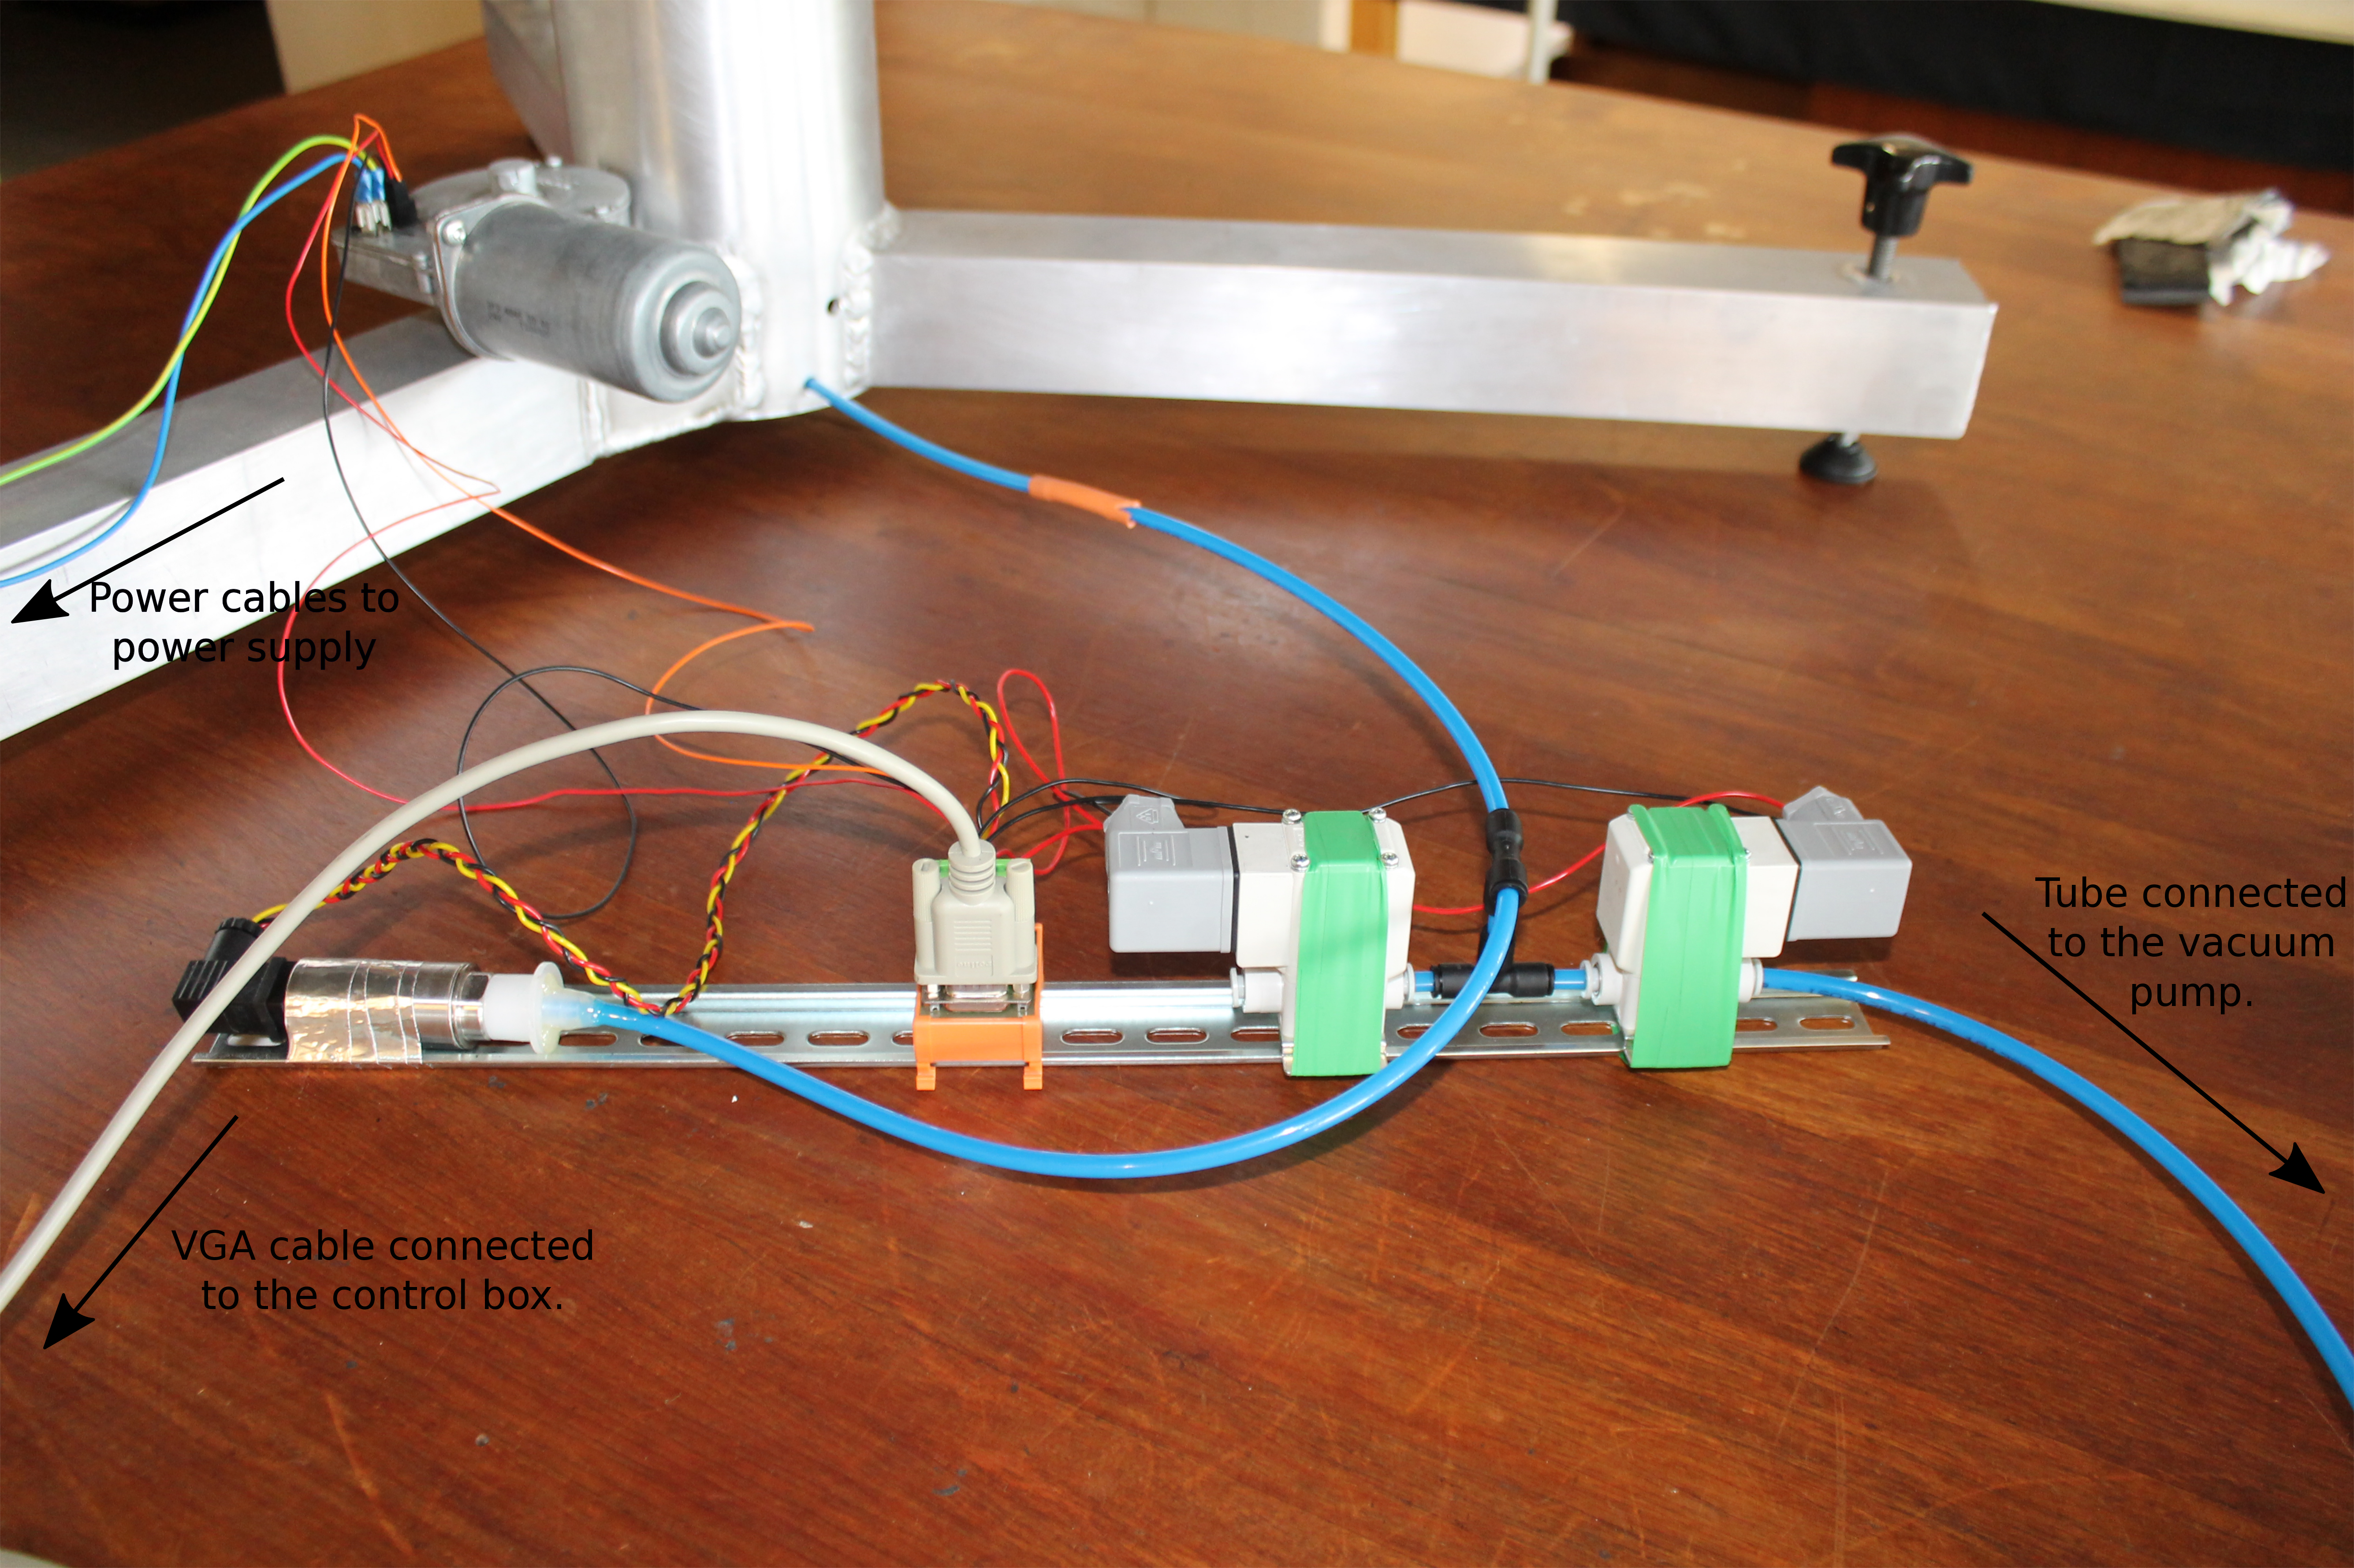

Setup of wires and tubes. (More detail below)

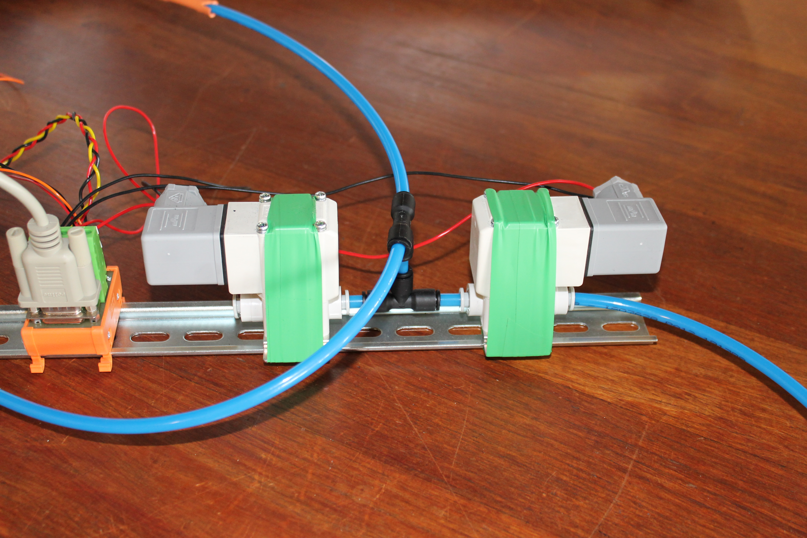

Connect the pumps as shown.

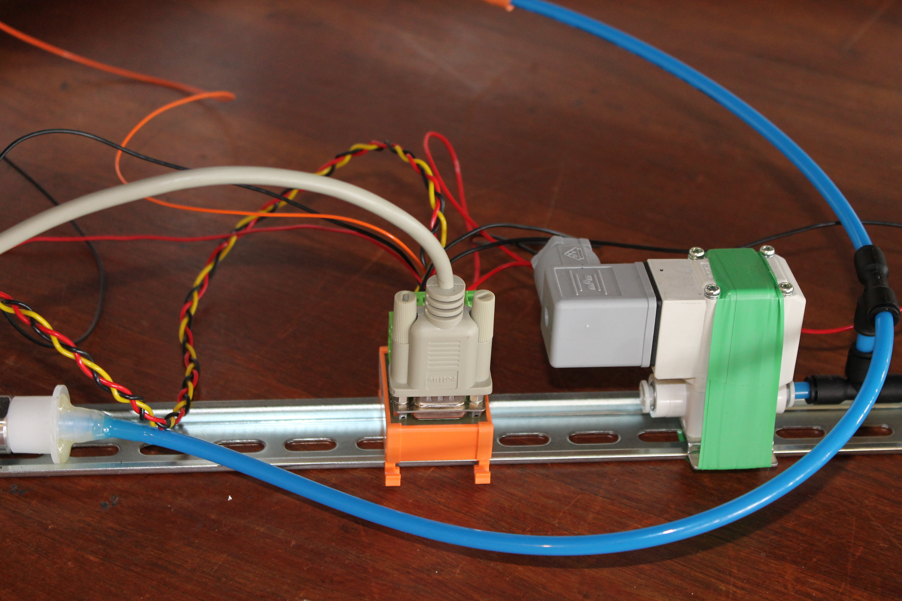

Connect the VGA cable as shown.

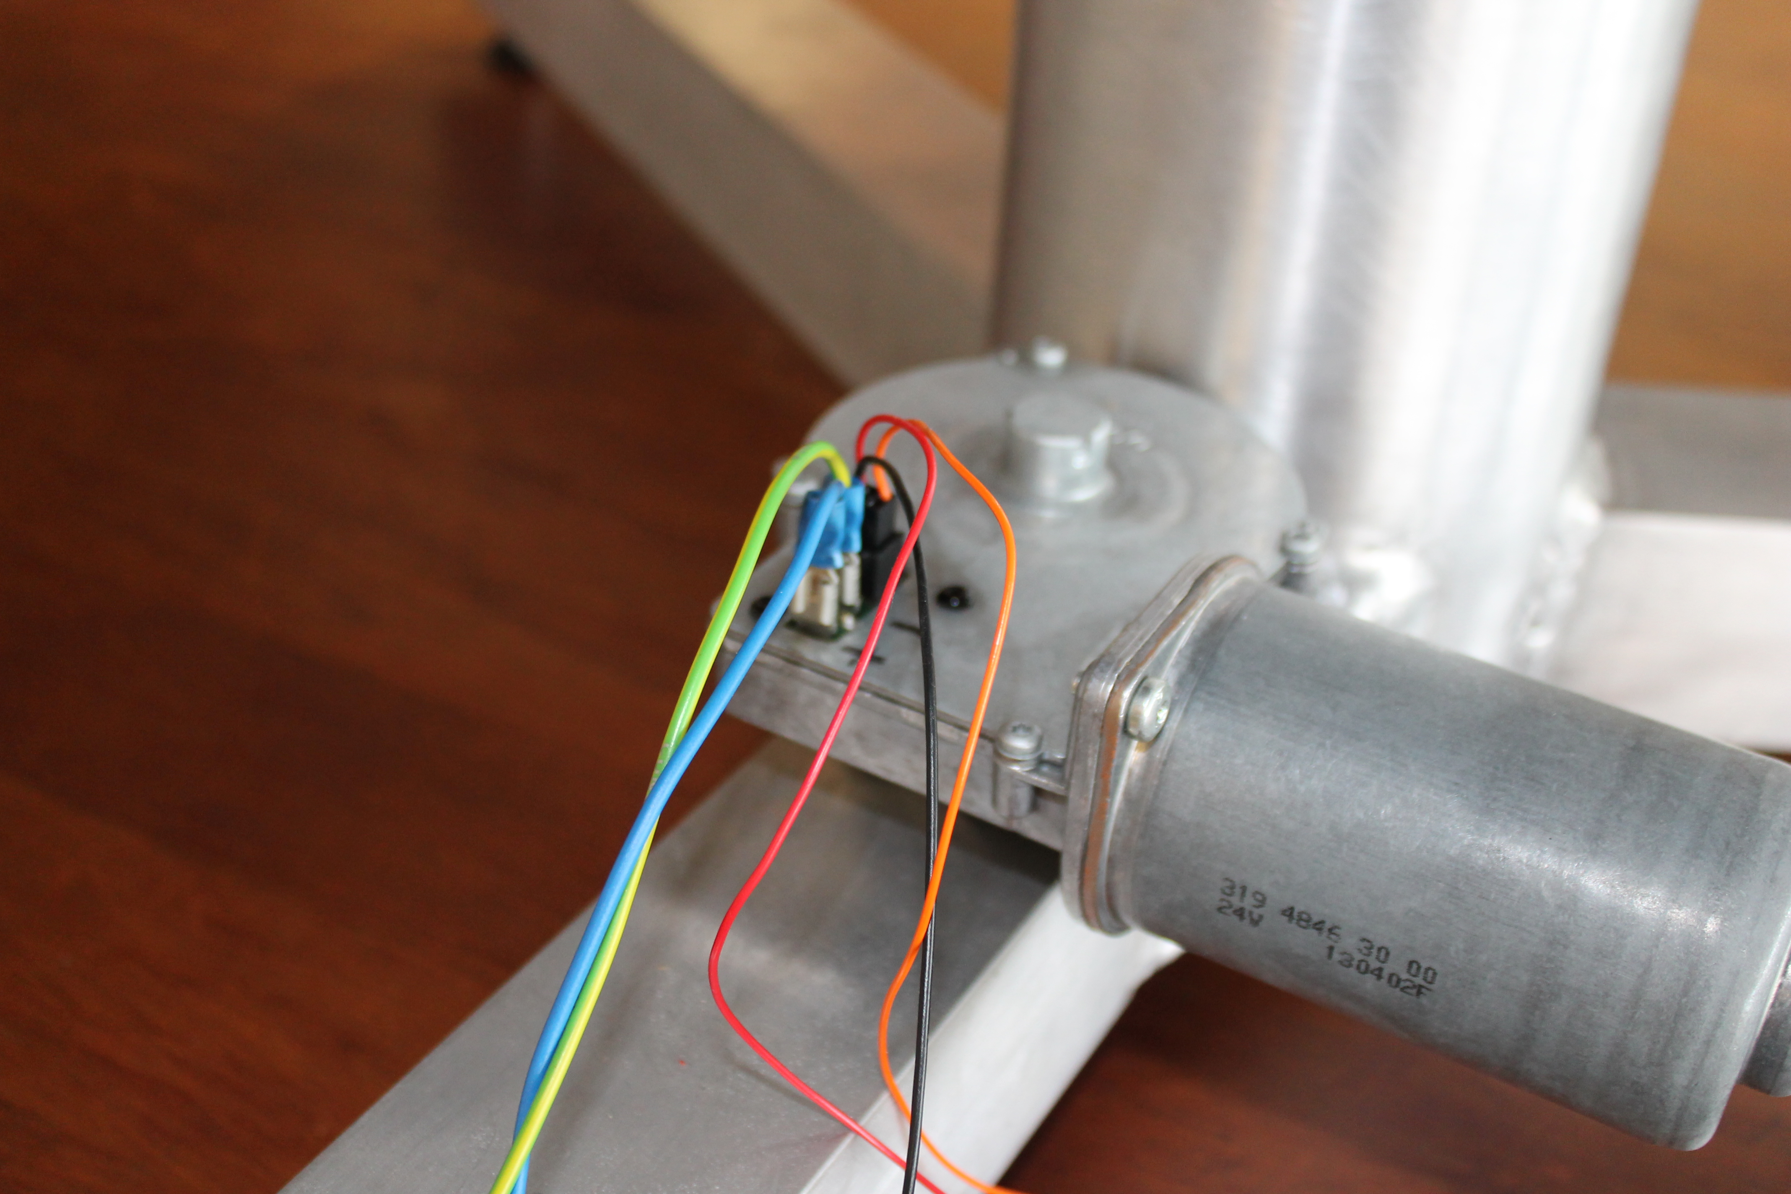

Motor. Connect the blue wire to positive, and the yellow and green wire to negative. Connect the red and orange wires as indicated.

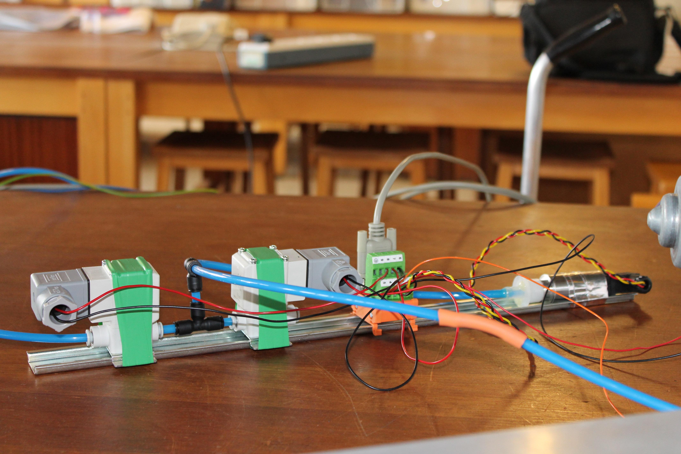

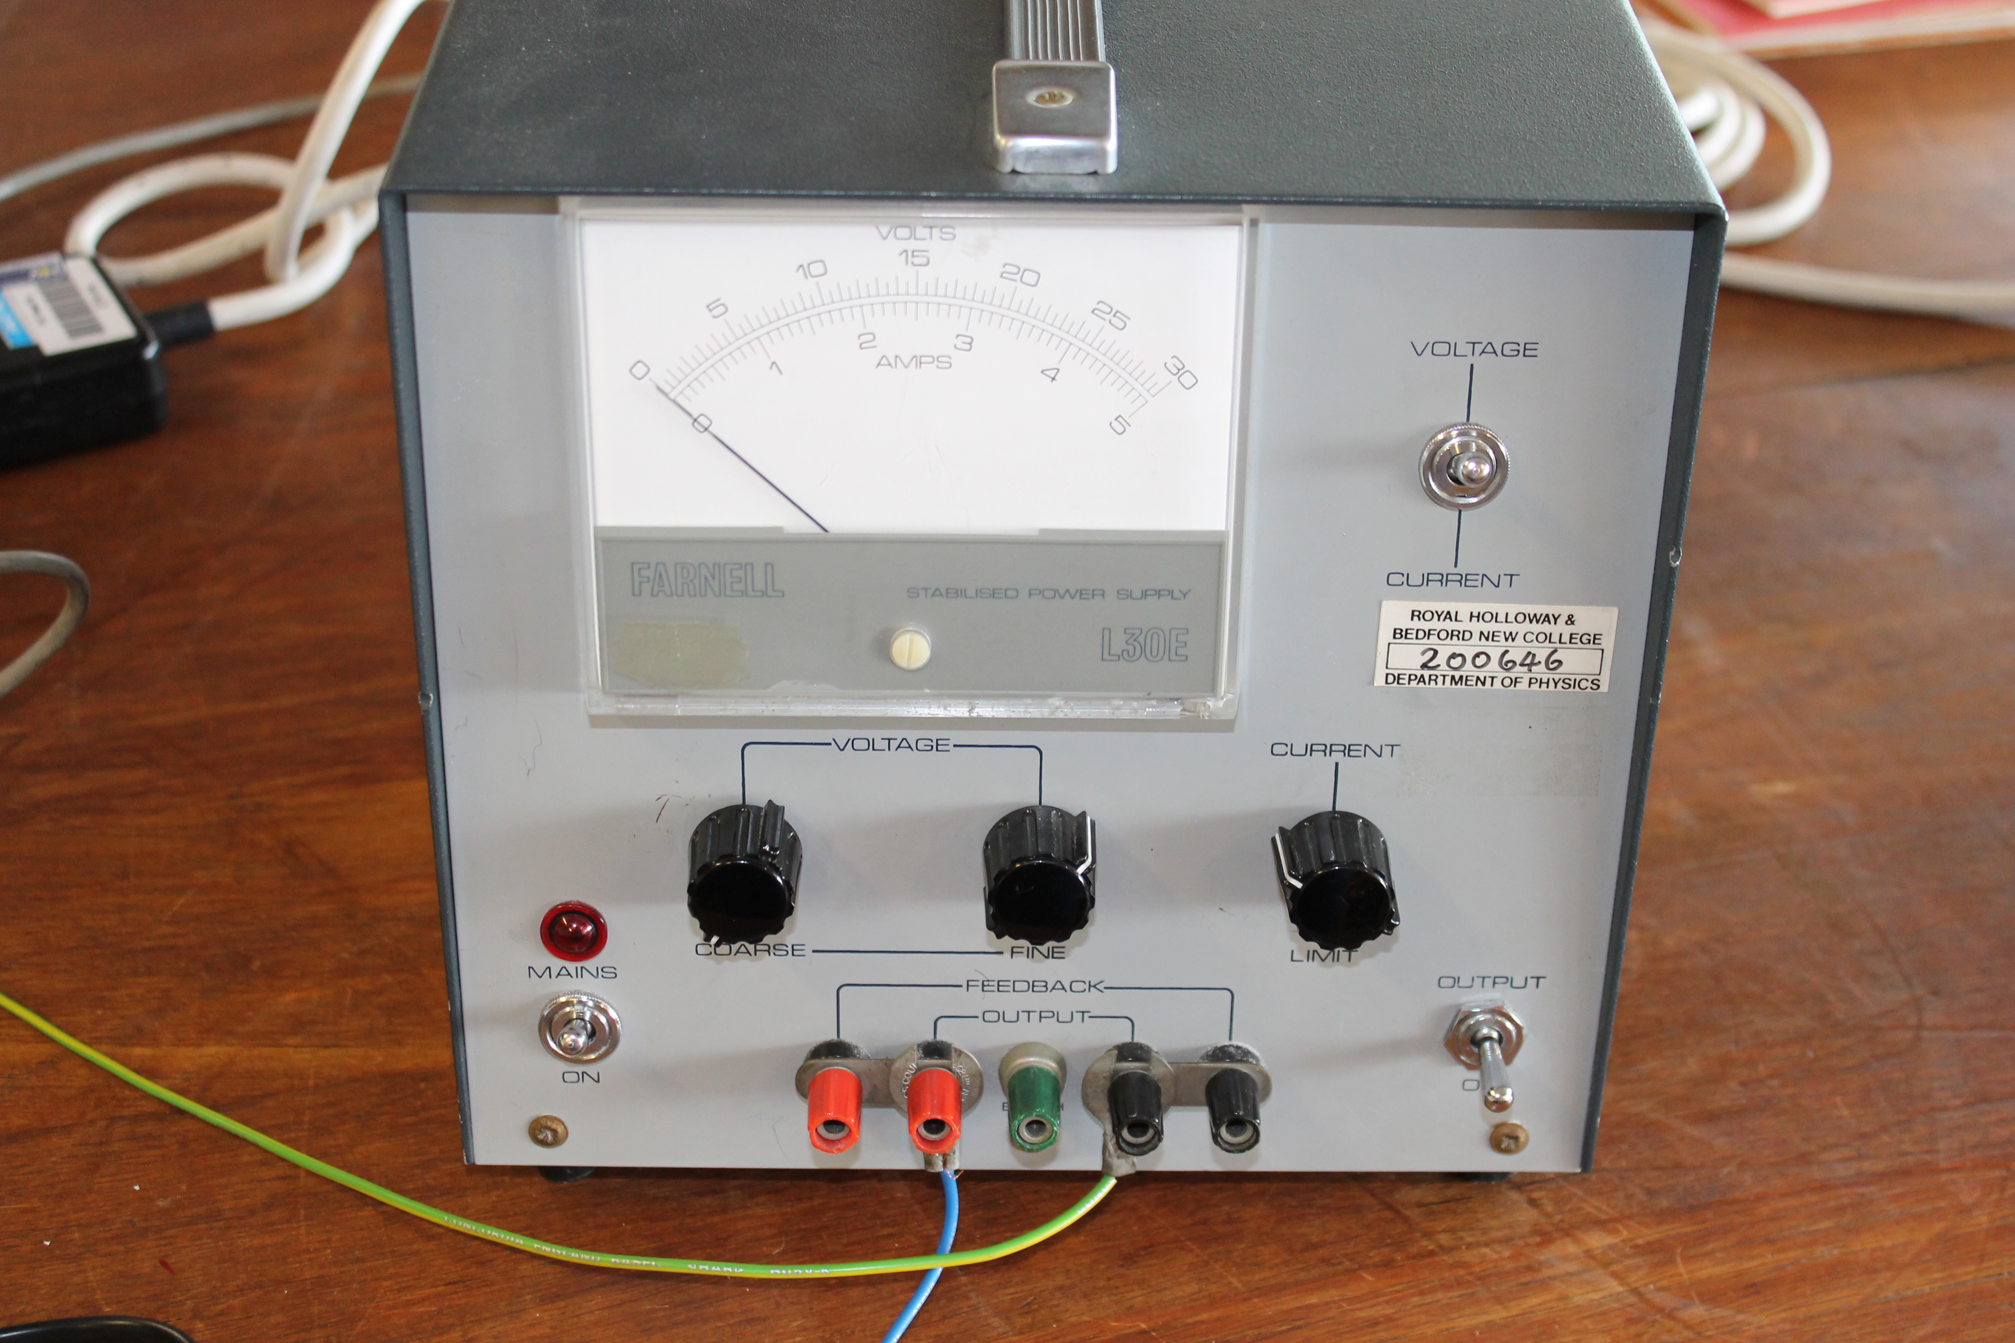

Power supply. Connect the motor of the machine to indicated ports.

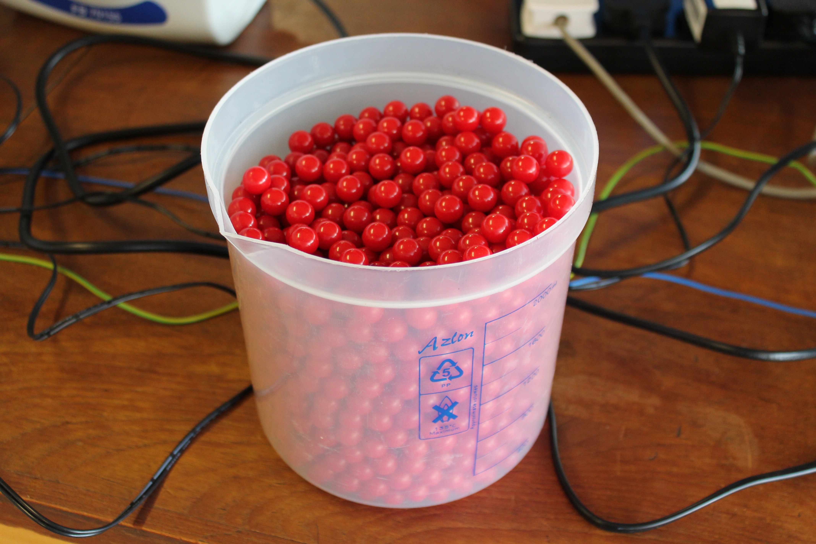

Red balls that represent stars.

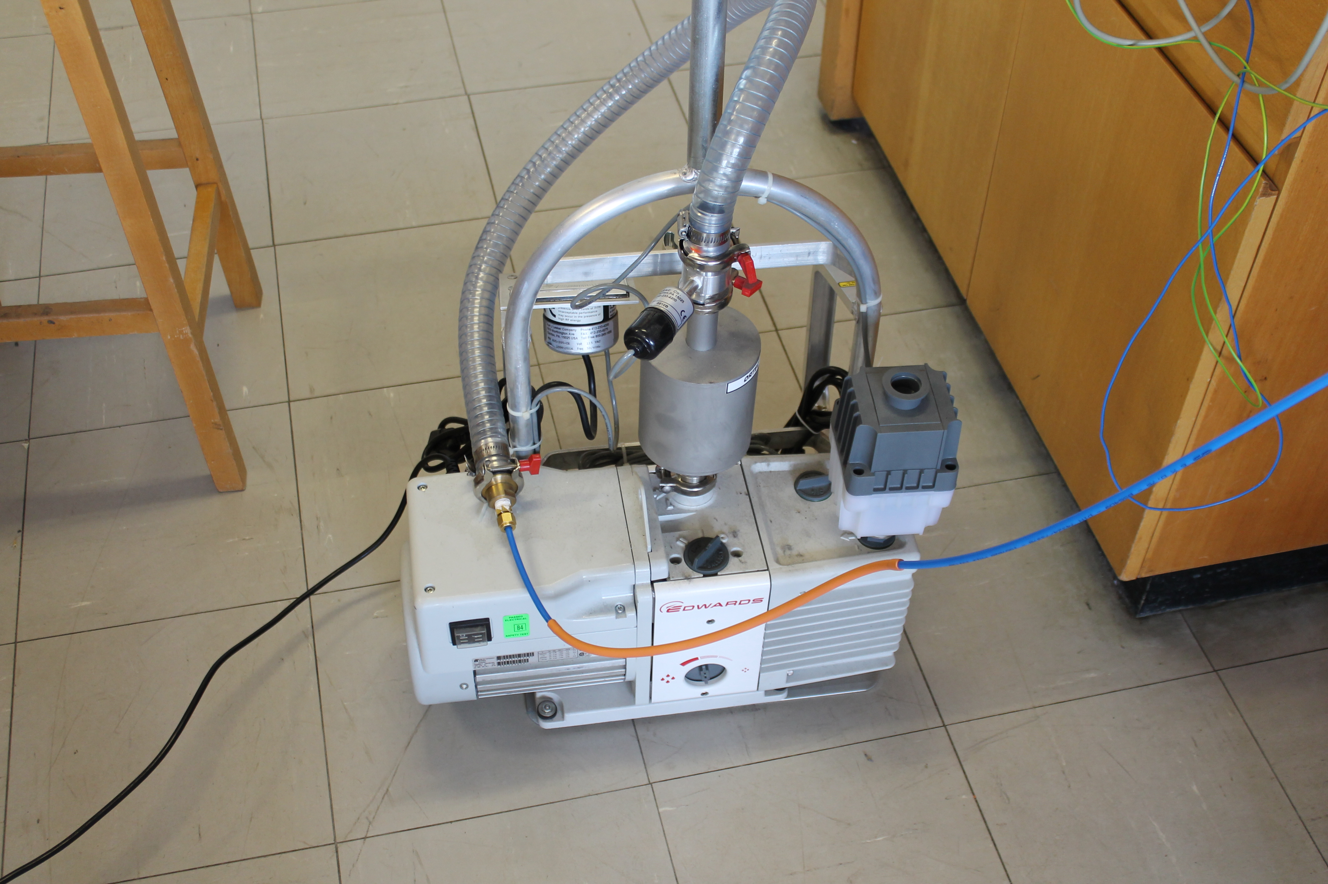

Vacuum pump.

Use

Ensure the position of switches should be as shown in the photo (both switched to the left to ensure the valves are open).

Ensure that, before power supply is turned on, ‘Coarse’ Voltage is turned down to 0 V. Switch on and slowly increase voltage to a MAXIMUM of 24 V.

Turn on the vacuum, and switch the vacuum switch on the control box to the right to open the air valve.

Vacuum Switch Opens and closes the valve connected to the vacuum pump.

Air Switch Opens and closes the air valve.

Reset Switch The reset switch was used to calibrate the pressure gauge to atmospheric pressure before starting.  The pressure control code is not active on the micro controller now though, so that switch doesn't do anything.

Gradient Knob

The Ethernet port is how the micro controller communicates with the LED display.  It also can allow a laptop to control the micro controller directly, though that was mostly just for testing.

There aren't any real optimal speeds or settings, as that depends on the number of 'stars' that one loads. Changing the speed can demonstrate how different escape velocities affect the evaporation rate.  In general there isn't a specific single thing that this demonstrates, but a few different competing effects that can be messed with and explored.

The micro controller was originally programmed to control the 'depth' by opening and closing the valves to keep a specified differential pressure. Unfortunately, that pressure gauge is not quite sensitive enough, is not really in the right spot (it should be actually inside the main volume) and the pump/ fill line should be bigger.

It's a plain Arduino, so if one wants to, one may program it.